ASSIGNMENT-1

Load each dataset and observe the following:

**FOR IRIS DATASET:**

First open the iris arff file from Weka

1. **List the attribute names and their types**

|  |  |
| --- | --- |
| **Attribute Name** | **Attribute Type** |
| sepallength | Numeric |
| sepalwidth | Numeric |
| petallength | Numeric |
| petalwidth | Numeric |
| class | Nominal |

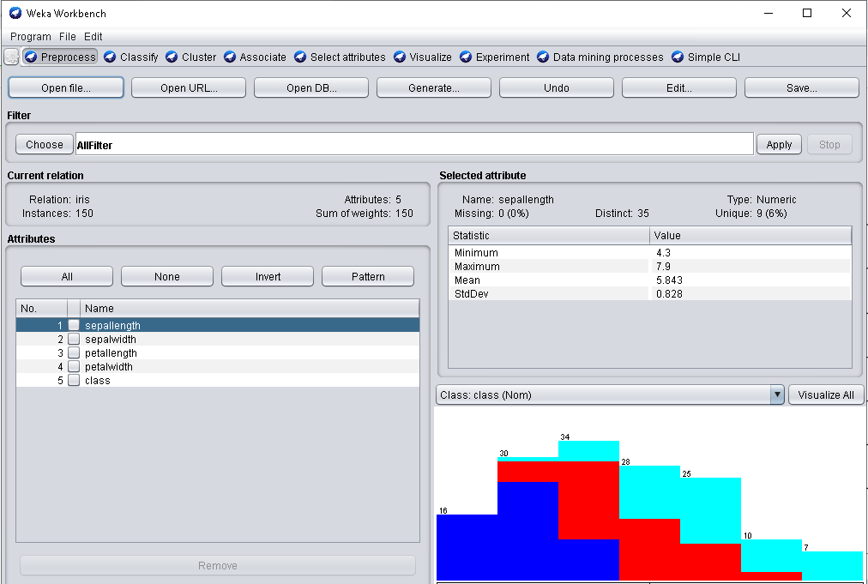

1. **Number of records in the dataset**

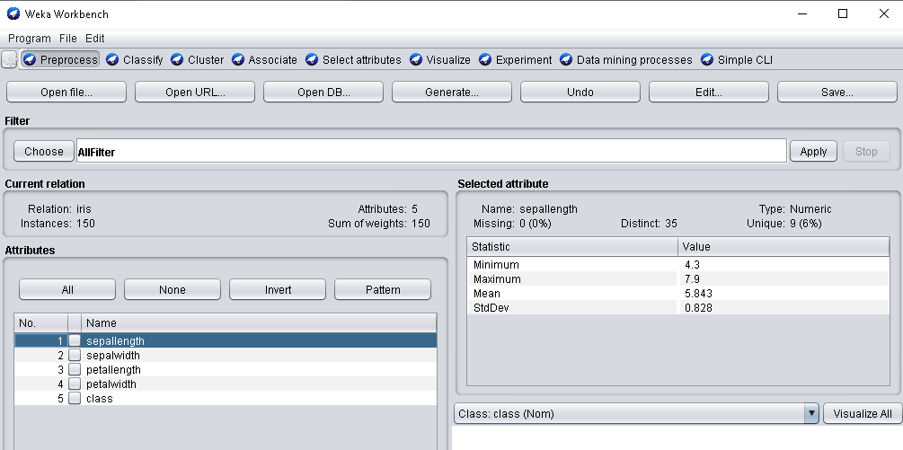

There are 150 records.

1. **Identify the class attribute in the dataset: class**

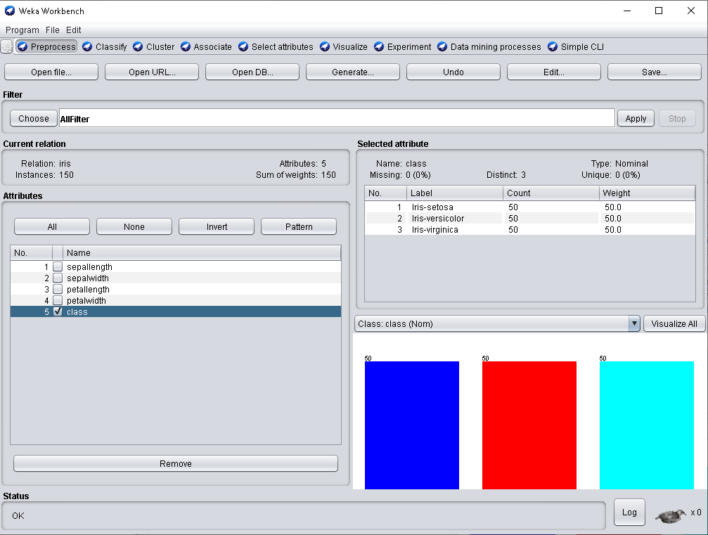

1. **Graphical histogram representation of all attributes against class attribute.**

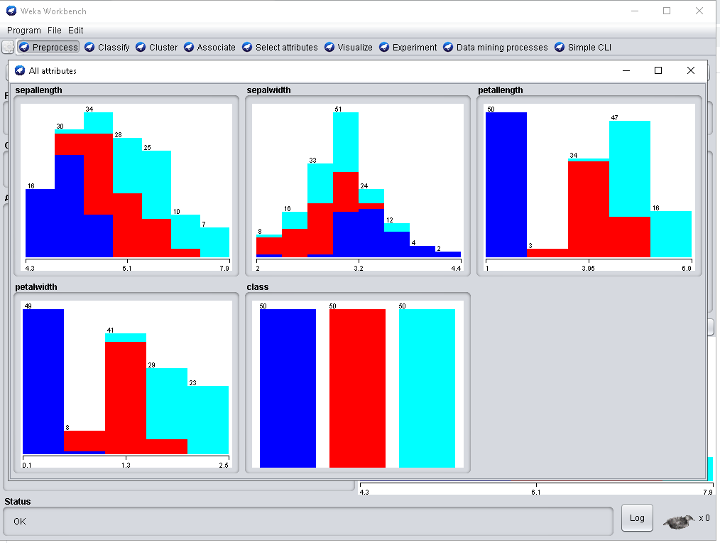

1. **Determine the number of records for each class:**

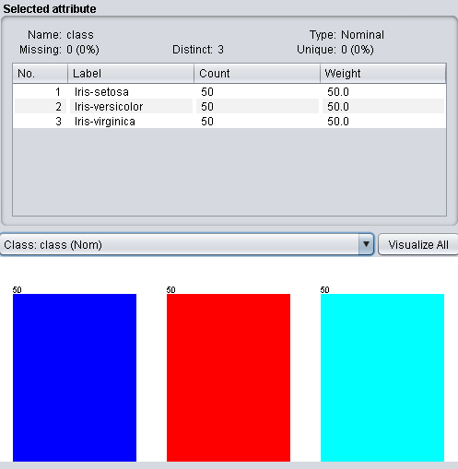

1. Iris-setosa-50 records
2. Iris-versicolor-50 records
3. Iris-virginica-50 recods

**FOR GERMAN CREDIT DATASET:**

1. **List the attribute names and their types:**

|  |  |
| --- | --- |
| **Attribute Name** | **Attribute Type** |
| checking_status | Nominal |
| Duration | Numeric |
| credit_history | Numeric |
| purpose | Nominal |
| credit_amount | Numeric |
| saving_status | Numeric |
| employment | Nominal |
| installment_commitment | Numeric |
| personal_status | Nominal |
| other_parties | Nominal |
| residence_since | Numeric |
| property_magnitude | Nominal |
| age | Numeric |
| other_payment_plans | Nominal |
| housing | Nominal |
| existing_credits | Numeric |
| job | Nominal |
| num_dependents | Numeric |
| own_telephone | Nominal |
| foreign_worker | Nominal |
| class | Nominal |

1. **Number of records in the dataset.**

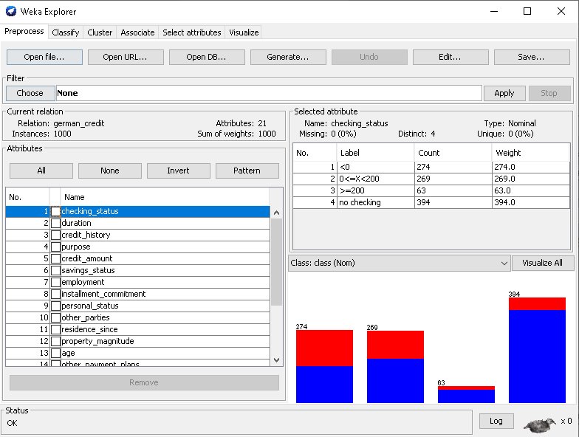

Therefore there are 1000 records.

1. **Identify the class attribute in the dataset:class**

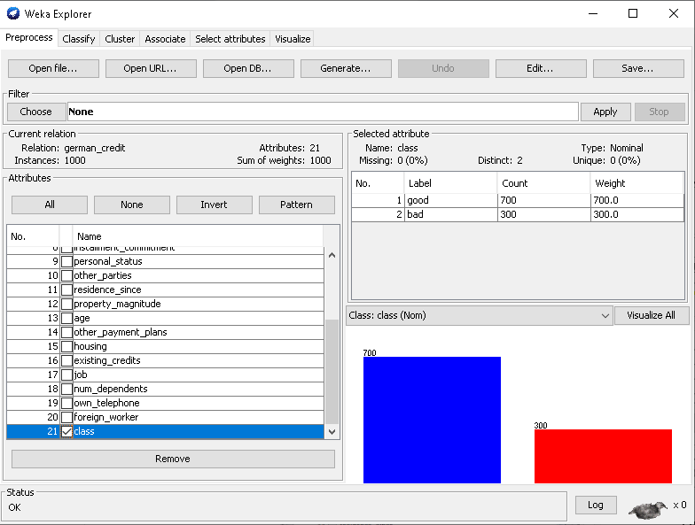

1. **Graphical histogram representation of all attributes against class attribute.**

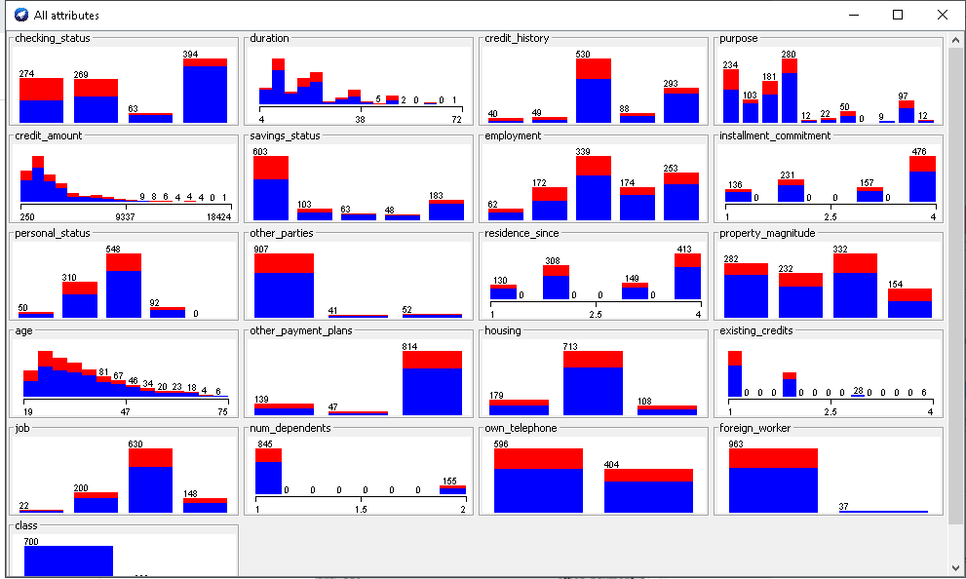

1. **Determine the number of records for each class:**

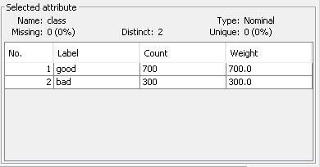

Good – 700 records.

Bad – 300 records.